**ASSIGNMENT 1**

USING KERAS

**Problem 1:**

Model 1:

Using Keras to build a MLP for classifying the CIFAR-10 dataset. Each record is of size 1*3072. Building a MLP to classify the data into the 10 classes.

DATASET:

CIFAR-10 dataset The CIFAR-10 dataset consists of 60000 32x32 colour images in 10 classes, with 6000 images per class. There are 50000 training images and 10000 test images.

The dataset is divided into five training batches and one test batch, each with 10000 images. The test batch contains exactly 1000 randomly-selected images from each class. The training batches contain the remaining images in random order, but some training batches may contain more images from one class than another. Between them, the training batches contain exactly 5000 images from each class.

<http://www.cs.utoronto.ca/~kriz/cifar.html>

Modify the following parameters and discuss the effect of changing parameters on loss and

Accuracy:

|  |  |  |  |  |  |  |  |
| --- | --- | --- | --- | --- | --- | --- | --- |
|  | No of epochs | Batch size | Number of neurons | Number of layers | Learning rate | Activation functions | Dropout rates |
| Model 1 | 25 | 64 | 3,402 | 12 | 0.0001 | relu, softmax | 0.2 |
| Model 2 | 5 | 128 | 3,402 | 12 | 0.0001 | relu, softmax | 0.3 |

* Based on the above results, MLP model 2 performed well and gave an accuracy of 50.28%
* MLP using relu & softmax activation functions improved the results.

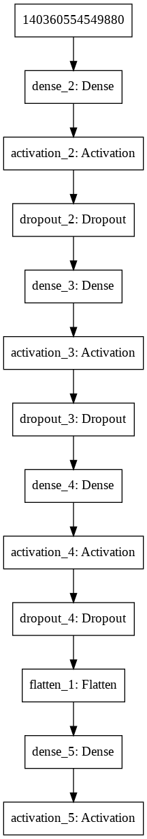

Model Fitting:

Train on 50000 samples, validate on 10000 samples

Epoch 1/5

50000/50000 [==============================] - 34s 689us/step - loss: 1.6644 - acc: 0.4138 - val_loss: 1.4811 - val_acc: 0.4805

Epoch 2/5

50000/50000 [==============================] - 34s 673us/step - loss: 1.4578 - acc: 0.4890 - val_loss: 1.4363 - val_acc: 0.4938

Epoch 3/5

50000/50000 [==============================] - 34s 673us/step - loss: 1.3904 - acc: 0.5160 - val_loss: 1.4460 - val_acc: 0.4929

Epoch 4/5

50000/50000 [==============================] - 34s 673us/step - loss: 1.3499 - acc: 0.5296 - val_loss: 1.4275 - val_acc: 0.4980

Epoch 5/5

50000/50000 [==============================] - 34s 675us/step - loss: 1.3076 - acc: 0.5456 - val_loss: 1.4191 - val_acc: 0.5058

Plotting:

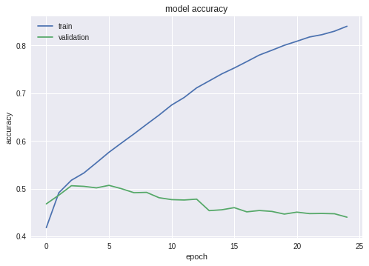

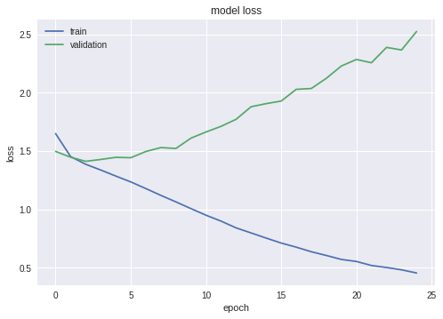

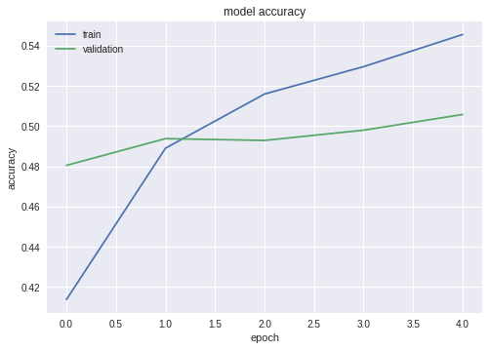

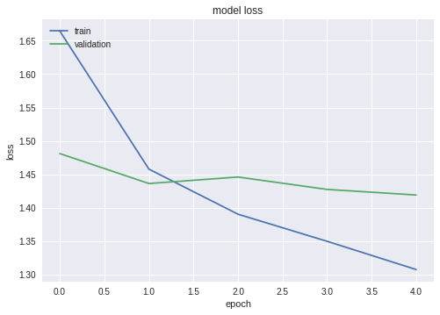

Results:

1) Provide a recommendation for the best model you would recommend for classification. Which model (with parameter values) would you choose and why?

According to me, the model that worked best for MLP was model 2. It had an accuracy of 44%.The best parameters that helped improve the model are:

epochs = 25

batch_size =

64 keep_probability =

0.7 learning_rate = 0.001

Optimizer

• Comment on how good your model is ? Does it overfit/underfit data ? What could you do to improve the model?

I ran it for 60 epochs and got almost 44.02% accuracy. To improve the model the learning rate should be improved. Also, number of neurons can be more complicated for a better fit. Along with these parameters, the number of epochs can also be increased for the model to train better.